**CS150 LAB ASSIGNMENT 6 Spring2016**

**Your assignment for this lab, is to create an enhanced C++ program, similar to our previous lab assignment** - once again, the program calculates the billing amount for cable company customers. This time you will use functions for each customer category. You will create an enhanced version similar to the example programs that were covered in lecture. Important – read all of this short document. The program should print the billing amount to two decimal places, which is standard for monetary amounts. Additional requirements for this lab include:

* Input is from an input data file. Prompt the user for the name of the input file.
* The program will read and process all customer records contained in the input file, and then write all information to the output file.
* You can use either if-else structure or switch structure for processing the customer data.
* Calculate the total number of types of accounts, number of customers belonging to each type and total billing amount.
* You will have to work with five functions including the main()
* Inside each function(Except the main()), calculate the billing amount and call the functions inside main() depending on the category. For example, if is government customer then call the government function.

**Instructions:**

Read this document completely before you begin work. Then read and run the template source code file (**lab06_2016_F_LName.cpp**) and look for comments that are the hints to solve the problem. You should also, refer to the sample output on the following page as you read through the lab assignment:

* Your program will prompt for the user name and ID, and write this information to the output file. (see example output)
* Your program will prompt the user to enter the name of the input file, so you must add code prompting the user to specify the input file name. Your program will read and process the information for all customers listed in the specified input file.
* The data in the sample input file describe one customer per line. See the complete program explanation in the textbook, the example programs provided by the author, and examine the **sample input** file : **lab6input.txt**
* For this lab, we will assume that the input files do not contain any errors, so don’t worry about having an invalid customer type.
* Calculate the billing amount for each customer.
* The program then writes the information and calculated values to the output file, including the original information read from the input, and the customers billing amount, total number of types of accounts, number of customers belonging to each type and total billing amount.
* The output written to the file **must be formatted as shown in** the **example output**.
* Format the output of decimal numbers to two decimal places.
* Write the output message to the screen as shown, and all other information is written to the output file named: **output1.txt**

Update the preliminary comments at the top of the template file with your information. Then fill out the programmer information inside the main function to print on the console. Your Programmer Output should look like that shown in the example output on the following page… but with your information filled in. This information is required on all lab assignments this semester. Save your source code file as **lab06_2016_F_LName.cpp**, replacing F and LName with your name before you submit it on Blackboard – or you will lose points on the lab.

* You will lose points for failing to do each or any of the following:
* Fill out the Preliminary Comments.
* Fill out the programmer info.
* Declaring function prototypes.
* Validate the opening of , and properly closing the input file stream variables properly .
* Name your source code solution file properly.
* Implement the required control structure (switch or if-else), according to the above documentation.
* In your source code - be sure to fill in an updated program description, your name and UIN, and the TA info or lose 25 points.

Your program should execute, and run properly to receive full credit. If your program doesn’t run, it may not be graded. You may create your own additional input files for testing purposes, however you are not allowed to change the structure of the input files. Do not change the example input files provided.

Submit your properly named source code file on Blackboard, following the instructions of your lab TA.

**Sample input file**

**lab6input.txt**

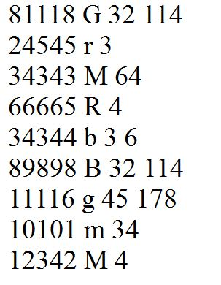

**Sample output file:**

**Output1.txt**

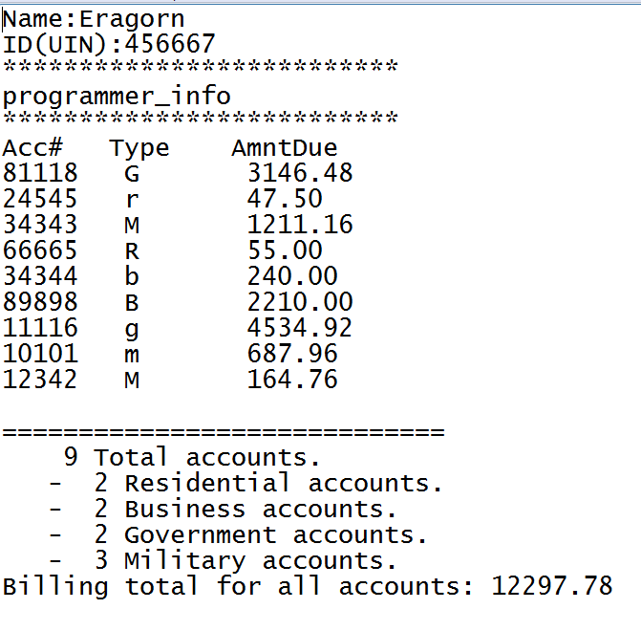

**Sample output sent to the console:**

